CASE STUDY
AI Customer Support Agent
Implementation

EXECUTIVE SUMMARY
Manual, fragmented support operations limited scalability and drove burnout.
Adya AI Customer Support Agent automated 68% of conversations through knowledge-driven, omnichannel AI with intelligent escalation.
Result: 82% faster responses, 55% faster resolution, and scalable 24/7 support without additional headcount.

1. Problem Statement

Industry / Customer Context
Mid-sized digital-first businesses managing high inbound customer queries across chat, email, WhatsApp, and voice. Support teams handling 8,000–15,000 monthly conversations with growing omnichannel complexity.

Core Problem Identified
Customer support operations were heavily manual, reactive, and fragmented across tools. High ticket volumes caused delayed responses, inconsistent communication, and operational strain.

Supporting Data Points (Baseline Metrics)
Metric | Baseline
Average First Response Time | 18–24 hours (email)
Average Resolution Time | 36–72 hours
Automation Rate | <10% (basic FAQ bots only)
Escalation Rate | 65% of total tickets routed to humans
Agent Utilization | Over 85% capacity consistently
Customer Satisfaction (CSAT) | 72–78%
After-hours coverage | Limited or none

Why It Mattered
- Operational scalability was capped by headcount
- Rising support volumes increased backlog risk
- Inconsistent responses affected brand perception
- Leadership lacked real-time visibility into performance
- High dependency on human agents created cost pressure

Support was no longer just a function — it was a growth bottleneck.

2. Impact of the Problem
(Functional, Emotional & Social Pain)

Operational Pain
- Repetitive queries consuming 60–70% of agent time
- Manual triaging and routing delays
- Fragmented systems across channels
- No centralized analytics view
- Rework due to inconsistent knowledge usage

Emotional Impact
- Leadership operating in constant firefighting mode
- Support managers lacked performance predictability
- Agents experiencing burnout from repetitive workloads

Social / Organizational Consequences
- Cross-team friction between Support and Operations
- Escalation overload to senior agents
- Delayed responses leading to public complaints

Cost of Inaction
If unchanged:
- 25–35% projected increase in ticket volume annually
- Hiring requirement of 3–5 additional agents within 12 months
- Escalating operational expenditure
- Gradual decline in CSAT below 70%

3. Solution Provided
(Pain Relievers & Gain Creators)

Solution Overview
Adya AI Customer Support Agent — a fully autonomous, omnichannel conversational AI platform designed to automate end-to-end customer support resolution with intelligent escalation.

Key Features Implemented
Knowledge-Driven Responses
→ Pain Relieved:
- Ingested help docs, FAQs, and website content
- Automated semantic search with vector embeddings
- Eliminated manual script-based bot limitations

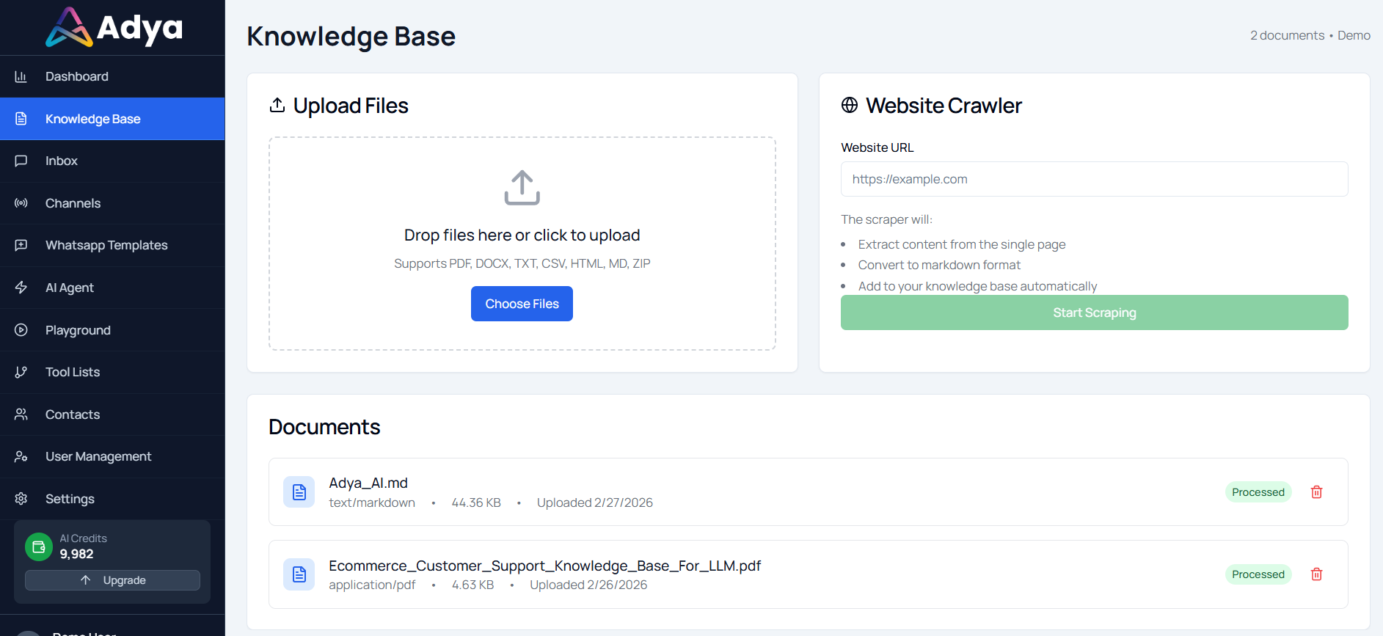
Omnichannel Deployment
→ Gain Created:
- Unified Chat, Email, WhatsApp, and Voice integration
- Consistent brand-aligned responses across all channels
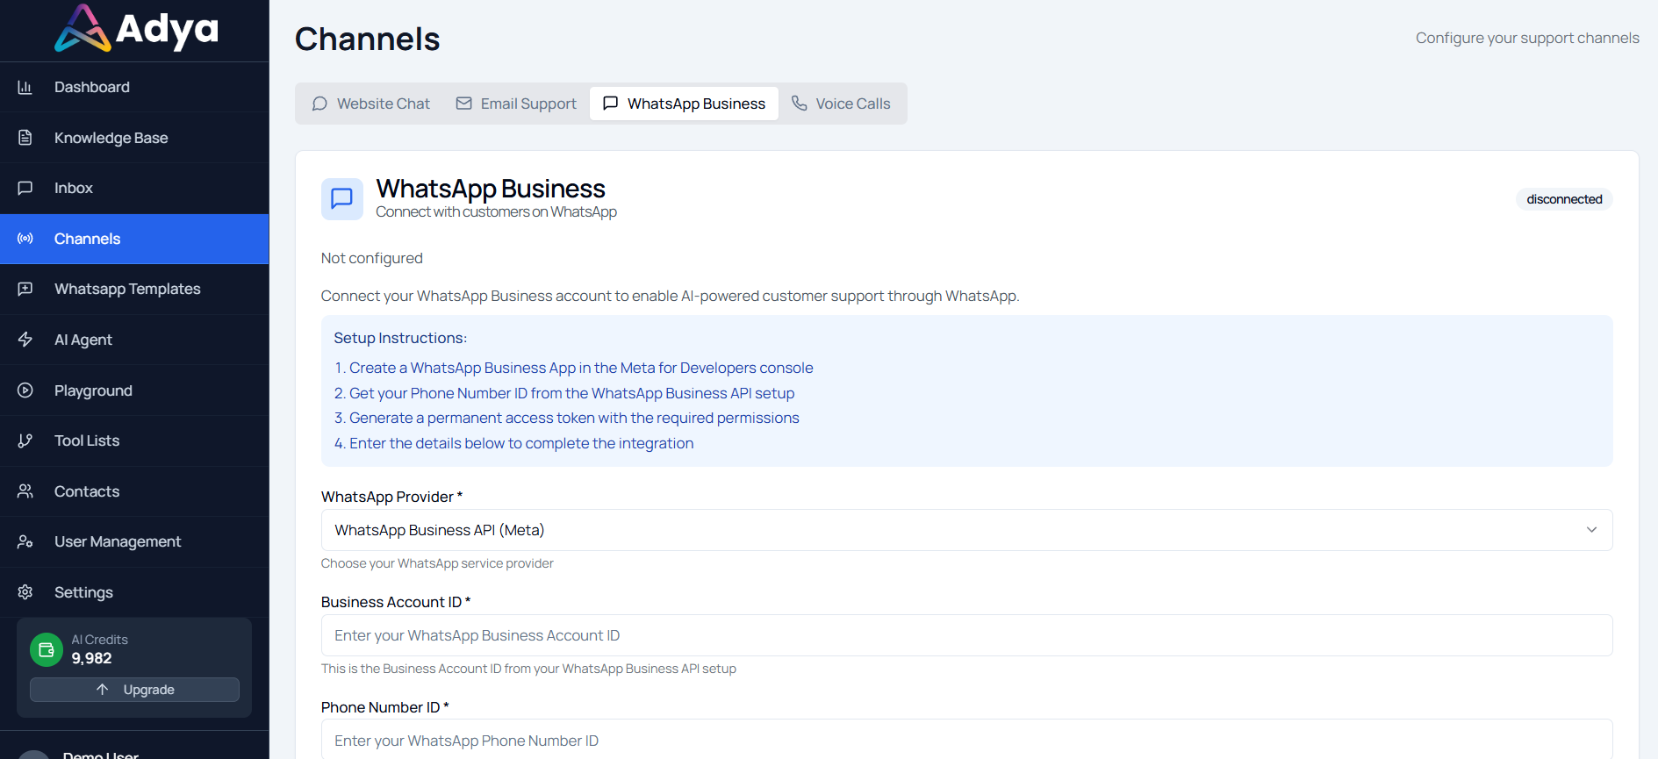

Autonomous Resolution Engine
→ Efficiency Impact:
- Intent detection and context-aware response generation
- Automated workflow execution (refund logic, eligibility checks)
- Reduced dependency on human intervention

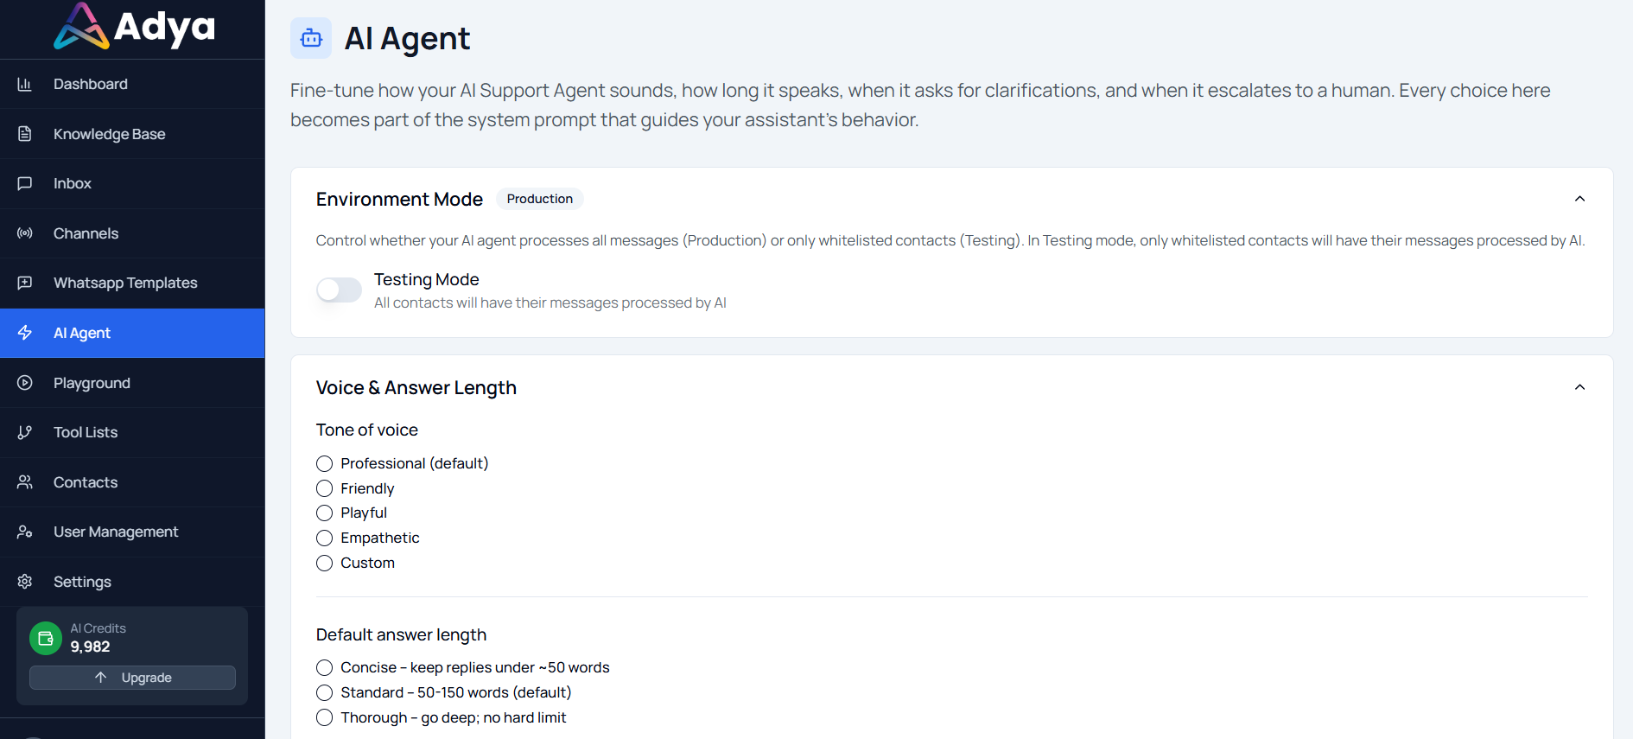
Intelligent Escalation System
→ Risk Mitigation:
- Confidence-based routing
- Frustration detection triggers
- Smart department-level assignment

Unified Inbox + Analytics Dashboard
→ Strategic Visibility:
- Real-time performance metrics
- AI vs Human resolution tracking
- Escalation analytics
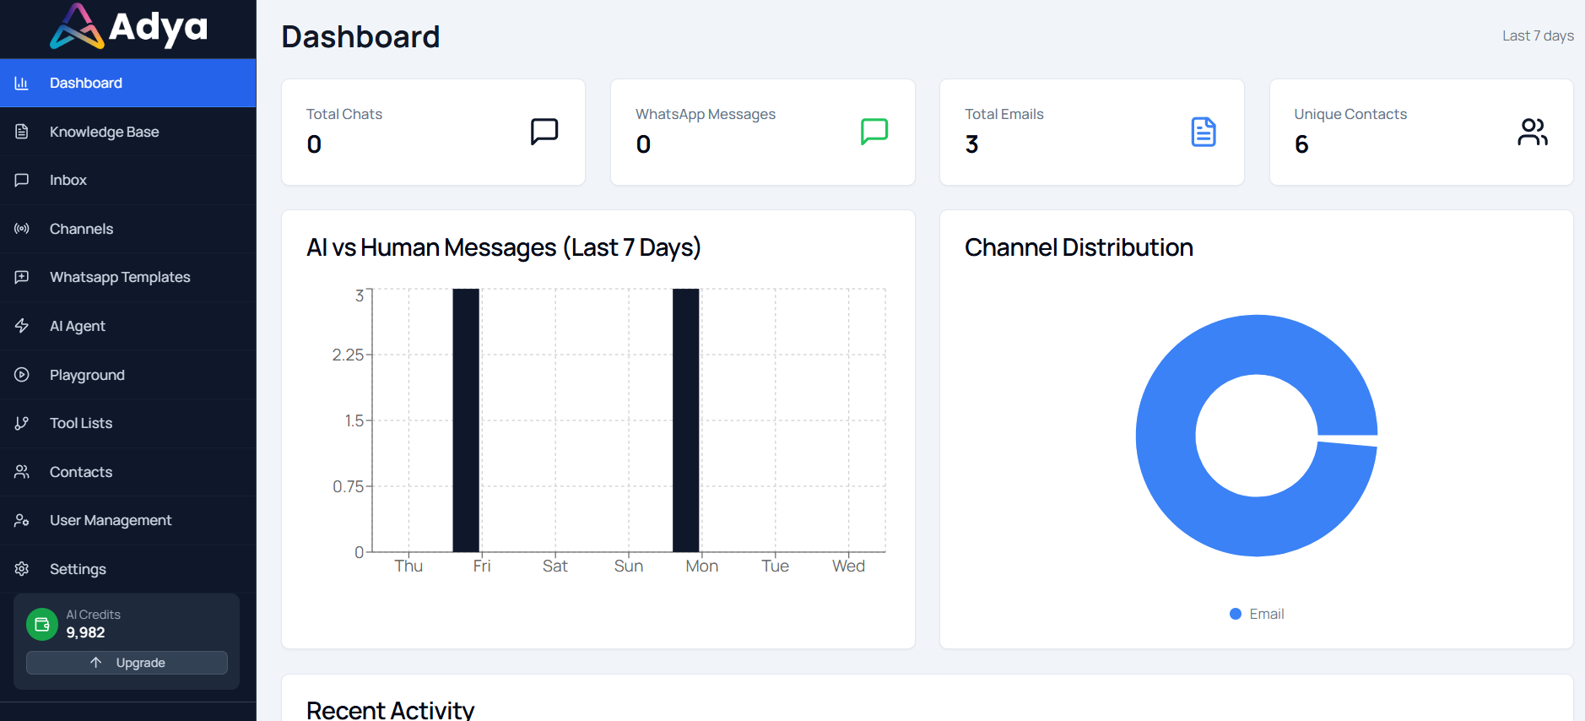

Implementation Approach
Timeline:
- Week 1: Knowledge ingestion & system configuration
- Week 2: Channel integrations & workflow setup
- Week 3: Personality configuration & testing (Playground)
- Week 4: Go-live with phased rollout

Integration Complexity: API-based integrations, No-code workflow builder, Minimal IT dependency

Change Management Strategy:
- Parallel AI + Human monitoring during rollout
- Knowledge base optimization sprints
- Escalation rule refinement post-launch

Technical Capabilities & Architecture
Layered AI Architecture

User Channels
↓
Channel Integration Layer
↓
Conversation Engine
↓
Knowledge Retrieval (RAG + Vector DB)
↓
Personality & Tone Layer
↓
Workflow Automation Engine
↓
Resolution Engine
↓
Human Escalation Layer
↓
Analytics & Inbox

Key Technical Components
- Retrieval-Augmented Generation (RAG)
- Vector Embedding Storage
- Intent Detection Engine
- Configurable Personality Layer
- Real-time Analytics Pipeline
- Automated Workflow Execution Logic

4. Outcome (Quantified Results)

Measurable Results (Within 90 Days)
Metric | Result
Automation rate (AI-resolved queries) | 68%
First Response Time reduction | 82% (18–24 hrs → <2 mins)
Average Resolution Time reduction | 55%
Escalation rate | 65% → 28%
Support team workload reduction | 40%
After-hours coverage | 24/7 (no additional hiring)

Strategic Impact
- Support operations scaled without increasing headcount
- Improved SLA compliance
- Enabled predictable support capacity planning
- Improved brand consistency across all channels
- Created structured support data for product insights

Human Impact
- Significant reduction in agent burnout
- Support teams shifted from repetitive queries to complex problem solving
- Improved collaboration via unified inbox
- Leadership gained real-time operational visibility
- Higher confidence in scaling customer experience

